Chapter-4 IS

DECISION SUPPORT AND INTELLIGENCE SYSTEM

- DSS (DECISION SUPPORT SYSTEM)

  - A decision support system (DSS) is a computer-based information system that supports business or organizational decision-making activities.

  - DSSs serve the management, operations, and planning levels of an organization (usually mid and higher management) and help people make decisions_{Science,NEC}aboutproblemsthat may be rapidly changing and not easily specified in advance— .e. Unstructured and Semi-Structured decision problems.

  - Decision support systems can be either fully computeriz d, human-powered or a combination of both.

  - Decision support system (DSS) – a highly flexible and interactive system that is designed to support decision making when the problem is not structured

  - Decision support systems help you analyze, but you must know how to solve the problem, and how to use the results of the analysis.

  - Using a DSS involves four basic types of analytical modelling activities
    - What-If Analysis:

    - Sensitivity Analysis:

    - Goal Seeking Analysis:

    - Optimization Analysis:

COMPONENTS OF A DSS

- Model management component – consists of both the DSS models and the model management system

- Data management component – stores and maintains the information that you want your DSS to use

- User interface management component – allows you to communicate with the DSS

1 Compiled By:-Shraddha Bikash Upadhyay ,Asst.Prof,NEC
Chapter-4 IS

TYPES OF DECISION

- Structured decision – processing a certain information in a specified way so that you will always get the right answer

- Non-structured decision – one for which there may be several “right” answers, without a sure way to get the right answer

- Recurring decision – one that happens repeatedly

- Nonrecurring (ad hoc) decision – one you make infrequently

PHASES OF DECISION MAKING
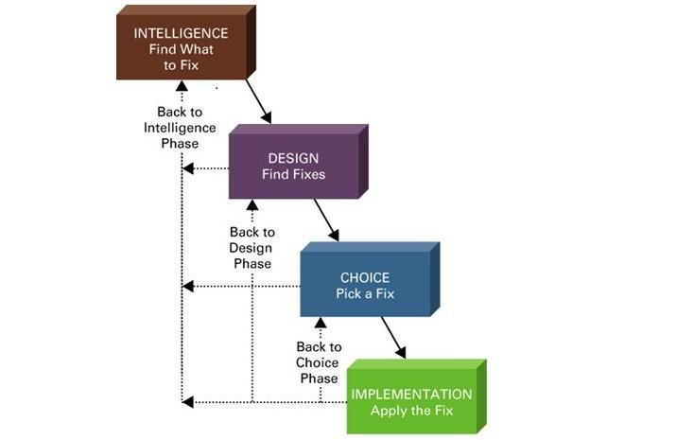

Intelligence – find or recognize a problem, need, or opportunity

Design – con ider possible ways of solving the problem

Choice – weigh the merits of each solution

Implementation – carry out the solution

EXAMPLES OF DSS APPLICATIONS:

Decisions support systems are used for a variety of applications in both business and government.

2
Chapter-4 IS

  - Institutional DSS - DSS which are developed to solve large or complex problems that continually face an organization.

  - Ad-hoc DSS - DSS which are quickly developed to solve smaller or less complex problems. They are also used to solve one-time situations.

  - Industry DSS - DSS which are developed to solve problems faced by a specific industry.

  - Functional DSS - DSS which are developed to solve problems in a specific functional area.

- GROUP DECISION SUPPORT SYSTEM

  - Group Decision-Support System (GDSS) is an interactive computer-based system used to facilitate the solution of unstructured problems by a set of decision makers working together as a group.

  - Group Decision support System (GDSS) are a class of electronic meeting systems ,a collaboration technology designed to supp rt meeting and group work

  - “Group Support system has come to mean computer software and hardware used to support group functions and processes”

  - High level Managers can spend 80 % of their time making decision in groups .Applied correctly ,GDSS can reduce this time, arriving at a better decision faster

  - GDSS provides the hardware,software,databases and procedure for effective decision making.

GDSS MEETING

- In a GDSS electronic meeting, each attendee has a workstation.

- The workstations are networked and are connected to the facilitator’s console, which serves as the facilitator’s workstation and control panel, and to the meeting’s file server.

- All data that the attendees forward from their workstations to the group are collected and saved on the file server.

3
Chapter-4 IS

- The facilitator is able to project computer images onto the projection screen at the front of the room.

- Many electronic meeting rooms have seating arrangements in semicircles and are tiered in legislative style to accommodate a large number of attendees.

- The facilitator controls the use of tools during the meeting. DIFFERENCE BETWEEN GDSS and DSS

- GDSS is a computer based information system that focuses on the group while DSS focuses on an individual for instance, the manager or the supervisor.

- GDSS and DSS may have similar components in terms of hardware and software structures

- GDSS has a networking technology that is best suited for group discussions or communication. DSS on the other hand, have technologies that are focused for a single user.

- GDSS maintenance involves a better system reliability and incomprehensible multi-user access compared to DSS because system failures in GDSS will involve a lot of individual.

- Through these programs or computer based information system, company or individual decision making capacities will be enhanced and hasten.

- This allows not only good communication system but also a positive outcome within a department, group, or company

SIMILARITY BETWEEN GDSS AND DSS

- Both use models, data and user-friendly software

- Both are interactive with “what-if “capabilities

- Both use internal and external data

- Both have flexible systems

- Both have graphical output

- Both allow the decision maker to take an active role

4
Chapter-4 IS
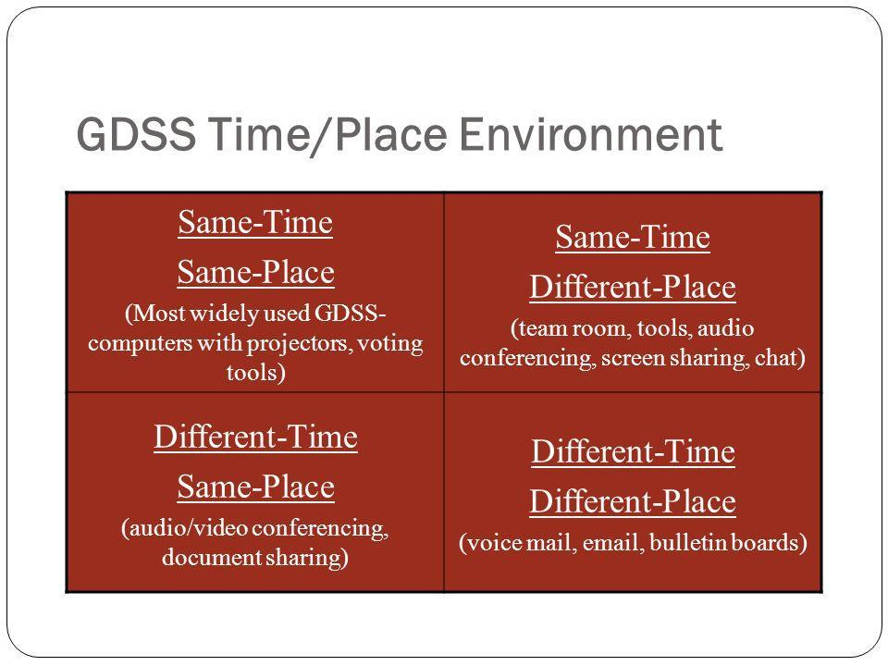

COMPONENTS OF GDSS

People

- The people may include decision-making participants and/or facilitator. A facilitator is a person who directs the group through the planning process

Procedures

• This refers to the ethods that have been used in holding meetings

Software

- The software part may contain of the following components: database and database ma agement capabilities, user/system interface with multi user access, specific applications to facilitate group decision-makers activities.

Hardware

- The hardware part may consist of the following components: I/O devices, PCs or workstations, individual monitors for each participant or public screen for group

5
Chapter-4 IS

ADVANTAGES OF GDSS

- Parallel Communication – eliminate monopolizing providing increased participation, better decisions

- Automated record keeping – no need to take notes, they’re automatically recorded

- Ability for virtual meetings – only need hardware, software and people connected

- Portability - Can be set up to be portable… laptop

- Global Potential - People can be connected across the world

- No need for a computer expert – although some basic experience is a must

- Anonymity – drive out fear leading to better decisions from a diverse hierarchy of decision makers

DISADVANTAGES OF GDSS

  - Cost –infrastructure costs to provide the hardware and software/room/network connectivity can be very expensive

  - Security – especially true when companies rent the facilities for GDSS; also, the facilitator may be a lower-level employee who may leak information to peers

  - Technical Failure – power loss, loss of connectivity, relies heavily on bandwidth and LAN/WAN infrastructure – properly setup system should minimize this risk

  - Keyboarding Skills – reduced participation may result due to frustration

  - Training – learning curve is present for users, varies by situation

  - Perception of messages – lack of verbal communication could lead to misinterpretation

- ENTERPRISE AND EXECUTIVE DECISION SUPPORT SYSTEMS

• An executive information system (EIS), also known as an executive support

system (ESS), is a type of management information system that facilitates and supports

senior executive information and decision-making needs.

6
Chapter-4 IS

- It provides easy access to internal and external information relevant to organizational goals. It is commonly considered a specialized form of decision support system (DSS).

- EIS emphasizes graphical displays and easy-to-use user interfaces. They offer strong reporting and drill-down capabilities.

- In general, EIS are enterprise-wide DSS that help top-level executives analyze, compare, and highlight trends in important variables so that they can monitor performance and identify opportunities and problems. EIS and data warehousing technologies are converging in the marketplace

- The growth of corporate intranets, extranets and the web (internet) has accelerated the development and use of “executive class” information delivery and decision support software tools to virtually every level of organization.

- An Executive Support System (ESS) is software that allows users to transform enterprise data into quickly accessible and executive-level reports, such as those used by billing, accounting and staffing departments. An ESS enhances decision making for executives.

- ESS is also known as Executive Information System (EIS).

- Executive information systems (EIS) are information systems that combine many of the features of information_{Ghimire,Dept}porting systems and decision support systems. EIS focus on meeting the strategic information needs of top management. The goal of EIS is to provide top management with immediate and easy access to information about a firm's critical success factors (CSFs), that is, key factors that are critical to accomplishing the organizations strategic objectives.

- Top executives get the information they need from many resources. These include, letters, memos, periodicals, and reports produced manually or by computer systems. Other major sources of executive information are meetings, telephone calls, and social activities. Thus, much of a top executive's information comes from non-computer sources. Computer-generated information has not played a major role in meeting many top executives' information needs. EIS were developed to meet the need that MIS was not meeting.

7
Chapter-4 IS
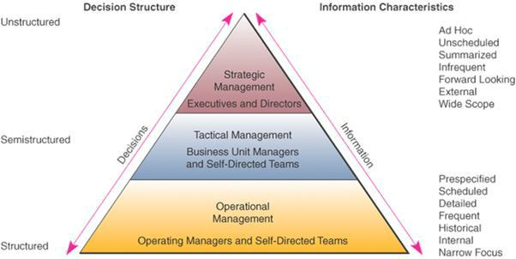

EXCECUTIVE DECISIONS: STRATEGIC LEVEL

- Inputs : Aggregate internal and external data

- Processing: Summarizing graphical interpreting

- Outputs: Summary reports trends , projections

- Users: Executive-level managers

8
Chapter-4 IS
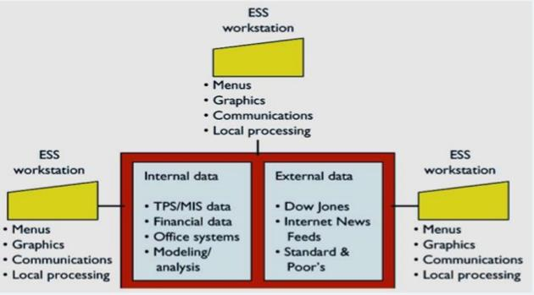

PESPECTIVE OF EXECUTIVE SUPPORT SYSTEMS

- Tailored to individual executives -Not to managers in other levels
- Can deliver both “soft” and “hard” data to the decision maker

- Drill down the capabilities
- Support need_{Ghimire,Dept}forexternaldata

- Can help when uncertainty is high

- Future-oriented ties CEO to all levels

- Linked to value –added processes

- Support for strategic control

- -Monitoring of internal and external events and resources and manage the overall orga izations

- Support for crisis management

- Put together a contingency plan

9
Chapter-4 IS

4.4. KNOWLEDGE MANAGEMENT, KNOWLEDGE BASED EXPERT SYSTEM
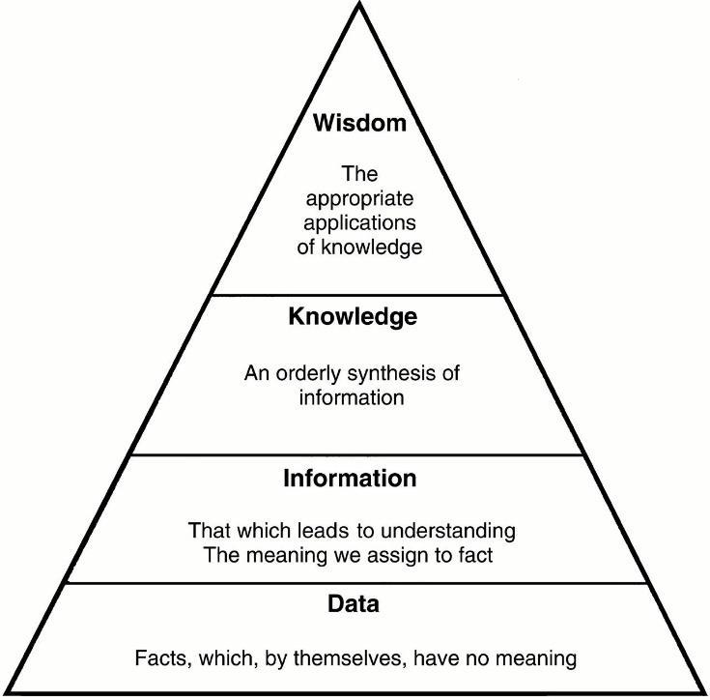
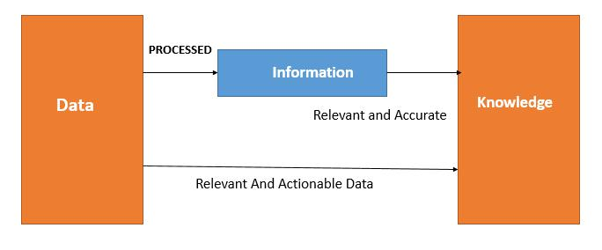

Data

- Refers to isolated facts such as individual measurement

- No meaning on their own

Information

- Fact about situation, persons, events Knowledge

- Experience

10
Chapter-4 IS

KNOWLEDGE MANAGEMENT

- Knowledge management (KM) is the process of capturing, developing, sharing, and effectively using organizational knowledge. It refers to a multi-disciplinary approach to achieving organizational objectives by making the best use of knowledge

- Knowledge Management(KM) comprises a range of strategies and practices used in an organization to identify, create, represent, distribute, and enable adoption of insights and
knowledge in an organization | Science,NEC
experiences
• KM is a process that helps organizations | identify, select organize ,disseminate , and

transfer important information and expertise that are part of the organization’s memory

• KM is the process of systematically and actively manag ng and leveraging stores of

BENEFITS OF KM SYSTEMS

- Enhanced Innovations and creativity

- Improved customer service, shorted product development and streamed line operations

- Enhanced employee retention

- Improved organizational performances

CHALLENGES OF KM SYSTEMS

- Getting employee buy-in

- Focusing too much on technology

- Forgetting the goal

- Dealing with knowledge overload and obsolescence

- “In a large or global organization, finding person with the right knowledge can be a significant challenge”

11
Chapter-4 IS

KNOWLEDGE BASED EXPERT SYSTEM

• A knowledge-based system (KBS) is a computer program that reasons and uses

a knowledge base to solve complex problems. The term is broad and is used to refer to

many different kinds of systems.

• A knowledge based system has two types of sub-systems: a knowledge base and

an inference engine. The knowledge base represents facts about the world. The inference

engine represents logical assertions and conditions about the world, usually represented via

IF-THEN rules.

• Knowledge-Based systems were first developed by Artificial Intelligence researchers. These early knowledge-based systems were primarily expert systems

• In fact the term is often used synonymously with expert systems. The difference is in the view taken to describe the system. Expert_{Computer}systemfrs to the type of task the system is trying to solve, to replace or aid a human expert in a complex task.

• Knowledge-based system refers to the architecture of the system, that it represents knowledge explicitly rather than as procedural code. While the earliest knowledge-based

systems were almost all expert systems, the same tools and architectures can and have since been used for_{Ghimire,Dept}awholeostofother types of systems. i.e., virtually all expert systems are knowledge-based systems but many knowledge-based systems are not expert systems.
EXPERT SYSTEM

Expert system are designed to solve complex problem by reasoning like an expert -Expert Systems Application Areas in Actions

- Medical Diagnosis

- Telephone Network Maintenance

  - Detection of common Metals

12
Chapter-4 IS
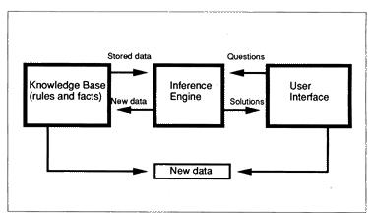

EXPERT SYSTEMS: CHARACTERISTICS

- Like an human expert, an expert system is expected to

- Be Specialist: known facts and procedural rules

- Use heuristics: interpolate from known facts

- Justify its conclusions: To establish credibility and confidence. The user can ask:

- Be able to learn: be able to absorb new knowledge and apply it estimate the reliability of its answer

An expert system could be defined as a program designed to model the problem solving ability of human expert. It is a clone to the expert of real life

Specialized knowledge on problem areas. Facts, rules, concepts and relationships. To

KNOWLEDGE store this in a KNOWLEDGE BASE, you need to learn KNOWLEDGE

REPRESENTATION

13
Chapter-4 | IS
 | How to reason with this knowledge.
 | Knowledge processor also called
REASONING | INFERENCE ENGINE. You need to learn
 | inference techniques.

WHY EXPERT SYSTEMS & NOT EXPERTS
- Always available

- Replaceable

- Consistent in performance

- Affordable cost

- Available anywhere

- Non perishable

- Work at a uniform speed

BASIC CONCEPTS OF EXPERT SYSTEMS

EXPERTISE: Expertise includes:
- Facts_{Ghimire,Dept}abouttheproblarea

- Theories about the problem area

- Hard-n-fast rules & procedures

- Rules of what to do in a problem situation

EXPERTS:

To mimic a human expert, it is necessary to build a system that exhibits a capability to:

- Recognize and formulate the problem

- Solve the problem quickly

- Explain the solution

- Learn from experience

14
Chapter-4 IS

- Restructure knowledge ,Break rules, Determine relevance

TRANSFERING EXPERTISE:

- The objective of an ES is to transfer expertise from the expert to the computer and then on to other humans. This includes:

  - Knowledge acquisition (from experts)

  - Knowledge representation (in the computer)

- In the knowledge base, you may have :

  - Facts

  - Procedures

REASONING:

- From knowledge base, the ES is programmed to make INFERENCES. The reasoning is performed in a component called INFERENCE ENGINE which includes procedures regarding problem solving by an approach called SYMBOLIC
REASONING.

EXPLANATION CAPABILITY:

• ES has the ability to xplain its advice or recommendations and even to justify

why a certain action was not recommended.

HUMAN ELEMENT IN EXPERT SYSTEMS

THE EXPERT

Also called DOMAIN EXPERT, a person possesses some special knowledge, judgment, experience and methods.

THE KNOWLEDGE ENGINEER:

The person who helps the human experts structure the problem area by :

- Interpreting

- Integrating human answers to questions

- Drawing analogies

- Posing counter examples

- Highlighting conceptual difficulties

15
Chapter-4 IS

THE USER

- Person may be using an ES as a :

- Consultant – one who seeks advice

- Instructor - one who wants to learn

- Partner - one who wants to improve KB

- Colleague - one who is an expert

PLANNING | PLANPOWER provides a wide range of
 | financial plans for households in the areas
 | of cash management
PREDICTION | PLANT predi ts the damage to corn
 | caused by the invasion of black cutworms
PRESCRIPTION | BLUE BOX recommends an appropriate
 | therapy for patients suffering from
 | depression
SELECTION | IREX assists in the selection of industrial
 | robots in a work environment. It identifies
 | the best choice from a list of possibilities
SIMULATION | STEAMER simulates and explains the
 | operation of the Navy’s 1078-class frigate
 | system propulsion plant to aspiring
 | NAVAL engineers

16
Chapter-4 IS

4.5. AI, NEURAL NETWORKS, VIRTUAL REALITY, INTELLIGENT AGENTS

ARTIFICIAL INTELLIGENCE (AI)

- Artificial intelligence (AI) is the intelligence exhibited by machines or software. It is also the name of the academic field of study which studies how to create computers and computer software that are capable of intelligent behavior.

- Major AI researchers and textbooks define this field as "the study and design of intelligent agents", in which an intelligent agent is a system that perceives its environment and takes actions that maximize its chances of success. John, who coined the term in 1955, defines it as "the science and engineering of making intelligent machines"

- It is the science and engineering of making intelligent ma hines especially intelligent computer program .It is related to similar task of using computers to understand human intelligence, but AI does not confine itself to methods that are biologically observable.

- Intelligence is the computational part of the ability to achieve goals in the world. Varying kinds and degrees of intelligence occur in people, many animals and some machines.

Artificial intelligence includes the following areas of specialization:

- games playing: programming computers to play games against human opponents

- expert systems: programming computers to make decisions in real-life situations (for example, some expert systems help doctors diagnose diseases based on symptoms)

- natural language: programming computers to understand natural human languages

- neural networks: Systems that simulate intelligence by attempting to reproduce the types of physical connections that occur in animal brains

- robotics: programming computers to see and hear and react to other sensory stimuli

NEURAL NETWORKS

- Artificial Neural Networks (ANNs) are a family of models inspired by biological neural networks (the central nervous systems of animals, in particular the brain) and are used to estimate or approximate functions that can depend on a large number of inputs and are generally unknown.

17
Chapter-4 IS

- Artificial neural networks are generally presented as systems of interconnected "neurons" which exchange messages between each other. The connections have numeric weights that can be tuned based on experience, making neural nets adaptive to inputs and capable of learning.

- For example, a neural network for handwriting recognition is defined by a set of input neurons which may be activated by the pixels of an input image. After being weighted and transformed by a function (determined by the network's designer), the activations of these neurons are then passed on to other neurons. This process is repeated until finally, an output neuron is activated. This determines which character was read.

Uses of NN

- Classification

- Pattern recognition, feature extraction, image matching

- Noise Reduction

- Recognize patterns in input and produce noiseless output.

VIRTUAL REALITY

- Virtual reality or virtual realities (VR), which can be referred to as immersive

multimedia or computer-simulated reality, replicates an environment that simulates a physical presence_{Ghimire,Dept}inplacesinthe real world or an imagined world, allowing the user to interact in that world. Virtual realities artificially create sensory experiences, which can include sight, hearing, touch and smell.

- The definition of virtual reality comes naturally from both ‘virtual’ and ‘reality'. The

definition of ‘virtual’ is near and reality is what we experience as human beings. So the term_{Anshu}‘Virtal Reality’ basically means ‘near-reality'. This could, of course, mean anything but it ually refer to specific type of reality emulation.

- “What is virtual reality” in technical terms is straight –forward. Virtual reality is the term

used to describe three –dimensional, computer generated environment which can be explored and interacted with by a person. That person becomes part of virtual world or is immersed within this environment and whilst there, is able to manipulate objects or perform series of actions.

18
Chapter-4 IS

USES OF VR

- Architecture

- Sport

- Medicine

- Arts

- Entertainment

Features of VR

  - There are many different types of virtual reality system but th y all share the same characteristics such as ability to allow the person to view three dimensional images. These images appear life-sized to the person

  - Plus they change as person moves around their environment which corresponds with the change in their field of vision.

  - A virtual environment should provide appropriate responses –in real time-as the person explores their surroundings

- DATA MINING, DATA WARE HOUSING, OLAP, AND OLTP

DATA MINING

- Data mining is an inte disciplinary subfield of computer science. It is the computational process of discovering patterns in large data sets ("big data") involving methods at the intersection of artificial intelligence, machine learning, statistics, and database systems.

- The overall goal of the data mining process is to extract information from a data set and

tra sform it into an understandable structure for further use. Aside from the raw analysis

step, it | involves | database and | data | management aspects, | data | pre-
processing, | model | and | inference | considerations, | interestingness

metrics, complexity considerations, post-processing of discovered structures, visualization, and online updating.

- Data mining is the analysis step of the "knowledge discovery in databases" process, or KDD.

19
Chapter-4 IS

- Data mining (sometimes called data or knowledge discovery) is the process of analyzing data from different perspectives and summarizing it into useful information - information that can be used to increase revenue, cuts costs, or both. Data mining software is one of a number of analytical tools for analyzing data.

- It allows users to analyze data from many different dimensions or angles, categorize it, and summarize the relationships identified. Technically, data mining is the process of finding correlations or patterns among dozens of fields in large relational databases.

- Non –trivial extraction of implicit, previously unknown and pot ntially useful information

from data

- It is result of natural evolution of Information Technology

WHY MINE

- Information is hidden

- Lots of time required for manual analysis

OUTCOME OF MINING

- Business Benefit

- Research Breakthrough

- Hypothesis creation

DATA WAREHOUSING

- In computing, a data warehouse (DW or DWH), also known as an enterprise data warehouse (EDW), is a system used for reporting and data analysis. DWs are central repositories of integrated data from one or more disparate sources. They store current and historical data and are used for creating analytical reports for knowledge workers throughout the enterprise. Examples of reports could range from annual and quarterly comparisons and trends to detailed daily sales analyses.

- The data stored in the warehouse is uploaded from the operational systems (such as marketing, sales, etc., shown in the figure to the right). The data may pass through an operational data store for additional operations before it is used in the DW for reporting

20
Chapter-4 IS

- Data warehousing is the way to provide architectures and tools for business executives to systematically organize, understand and use their data to make strategic decision.

- In today’s business world with competition mounting in every industry ,data warehousing is latest must-have marketing weapon-a way to retain customers by learning more about their needs

- A data ware house refers to a database that is maintained separately from an organization’s operational databases

- A data warehouse is a subject –oriented, integrated, time-variant, and non-volatile collection of data in support of management’s decision making proc ss.

- They allow for the integration of variety of application systems

- They support information processing by providing solid platform of consolidated historical data for analysis

OLAP

- Stands for "Online Analytical Processing." OLAP allows users to analyze database information from multiple database systems at one time.

- While relational databases are considered to be two-dimensional, OLAP data is multidimensional, meaning the information can be compared in many different ways. For example, a company might compare their computer sales in June with sales in July, then compare those results with the sales from another location, which might be stored in a different database.

- In order to process database information using OLAP, an OLAP server is required to orga ize and compare the information. Clients can analyze different sets of data using functions built into the OLAP server.

- Some popular OLAP server software programs include Oracle Express Server and Hyperion Solutions Essbase. Because of its powerful data analysis capabilities, OLAP processing is often used for data mining, which aims to discover new relationships between different sets of data.

21
Chapter-4 IS

- An OLAP system is market-oriented and used for data analysis

- It is used by knowledge workers, including managers, executives and analysts

- An OLAP system manages large amount of historical data, provides facilities for summarization, and aggregation and stores and manages information at different level of granularity

- OLAP make the data easier to use in informed decision making

- An OLAP system often spans multiple versions of database schema, due to the evolutionary process of an organizations

- OLAP systems also deal with information that originates from different organizations, integrating information from many data stores

OLTP

- Typically, OLTP systems are used for order entry, financial transactions, customer relationship management (CRM) and retail sales. Such systems have a large number of users who conduct short transactions. Database queries are usually simple, require sub-second response times and return relatively few records.

- An important_{Ghimire,Dept}attributeofanOLTP system is its ability to maintain concurrency. To avoid single points of failure OLTP systems are often decentralized.

- Because of huge volum , OLAP data are stored in multiple storage media

- An OLTP system is customer-oriented and is used for transaction and query processing by clerk,clients,and information technology professionals

- An_{Anshu}OLTPsystem manages current data that typically ,are too detailed to be easily used for deci ion making

- OLTP system usually adopts an entity relationship (ER) data model and an application

–oriented database design

- An OLTP system focuses mainly on the current data within an enterprise or department, without referring to historical data or data in different organizations.

22
Chapter-4 IS
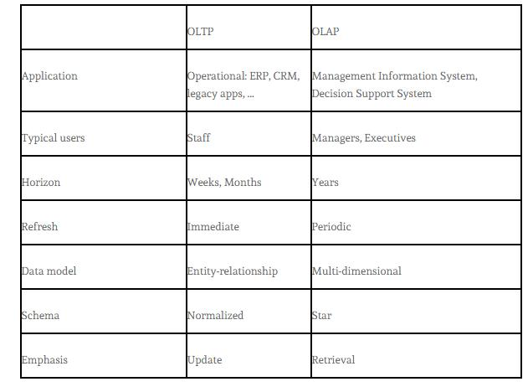

4.7. ANOMALY AND_{Ghimire,Dept}FRAUDETECTION

ANOMALY

• In data mining anomaly detection (or outlier detection) is the identification of items, events or observations which do not conform to an expected pattern or other items in a dataset. Typically the anomalous items will translate to some kind of problem such as bank fraud, a structural defect, medical problems or errors in a text. Anomalies are also referred to as outliers, novelties, noise, deviations and exceptions

• The set of data points that are considerably different than the remainder of the data.

• They are the points that don’t fall under some predefined categories

• Also referred to as outliers, exceptions, peculiarities, surprise etc.

CHALLENGES

- How many outliers are there in data?

23
Chapter-4 IS

- -Method is unsupervised

- -Validation can be quite challenging (just like for clustering)

- The boundary between normal and outlying behavior is often not precise

- -Data might contain noise

WORKING ASSUMPTIONS

- They are considerably more “normal” observations than “abnormal” observations (outliers/anomalies) in the data.

GENERAL STEPS

-Build a profile of the “normal” behavior

- Profile can be patterns or summary statistics for overall population -Use the “normal” profile to detect anomalies

- Anomalies are observations whose characteristics differ significantly from normal profile

TYPES OF ANOMALY DETECTION

- Graphical and statistical –based

- Distance based

- Model Based

GRAPHICAL APPROACH

- Boxplot(1-D)

- Scatter Plot(2-D)

- Spin Plot(3-D)

DISTANCE BASED APPROACHES

- Data is represented as vector of features

- Three major approaches
- Nearest neighbor based

- Density Based

- Clustering Based

APPLICATIONS OF ANOMALY DETECTION

- Network Intrusion detection

- Insurance/Credit card fraud detection

- Healthcare Informatics/Medical diagnostics

24
Chapter-4 IS

- Industrial Damage Detection

- Image Processing/Video surveillance

- Novel Topic Detection in Text Mining
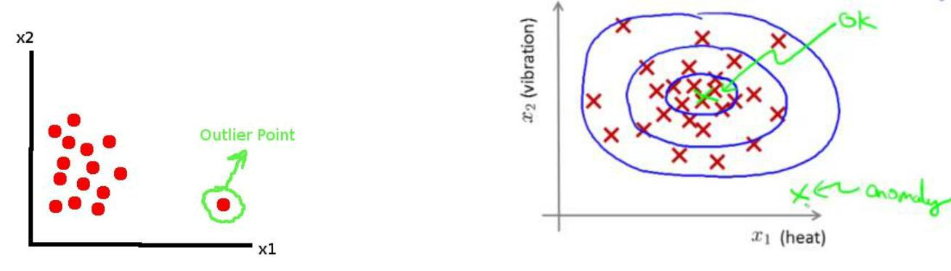

FRAUD DETECTION

- Internet transaction have recently raised big concerns, with some research showing that internet transaction fraud is 12 times higher than in-store fraud.

- This first industries to use data analysis techniques to prevent fraud where the telephone companies, the insurance companies and the banks.

TECHNIQUES USED FOR FRAUD DETECTION

- Two main classes -statistical techniques

-artificial intelligence

STATISTICAL TECHNIQUE

- Data processing technique for detection, validation, error correction, and filling up of missing or incorrect data.

- Calculation of various statistical parameters such as averages,quantiles,performance metrics ,probability distributions and so on

- Computing user profiles

- Times-series analysis of time –dependent data

- Clustering and classification to find patterns and associations among group of data

ARTIFICIAL INTELLIGENCE SYSTEM

- Data mining to classify, cluster and segment the data and automatically find associations and rules in the data that may signify interested patterns, including those related to fraud.

25
Chapter-4 IS

- Pattern recognition to detect approximate classes,clusters,or patterns of suspicious behavior either automatically (unsupervised) or to match given inputs

- Machine learning techniques to automatically identify characteristics of fraud

- Neural Network that can learn suspicious patterns from samples and used later to detect them.

26

